**Practical No: 8**

**Date: 18/04/2023**

**Aim: Create a backing Service using ASP .NET**

**Description:**

**Give Overview of Event Sourcing**

**Event Sourcing and CQRS Example Code & Output:**

**1)install erland broker using OTP AND Radis cache**

**2)then install rabbitmq server**

**3)open folder “C:\Users\Admin\AppData\Roaming\RabbitMQ\db” and delete everything inside it.**

**4)now run RabbitMQ sbin command prompt as administrator**

**5) and type following commands:**

**In rabbitmq command prompt**

**rabbitmq-plugins enable rabbitmq_management**

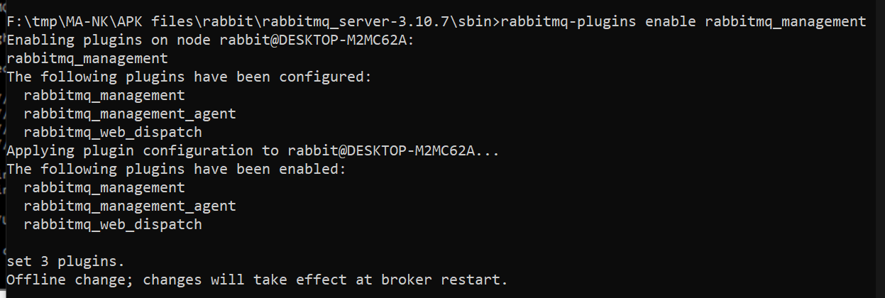

rabbitmq-service remove

rabbitmq-service install

rabbitmq-server restart

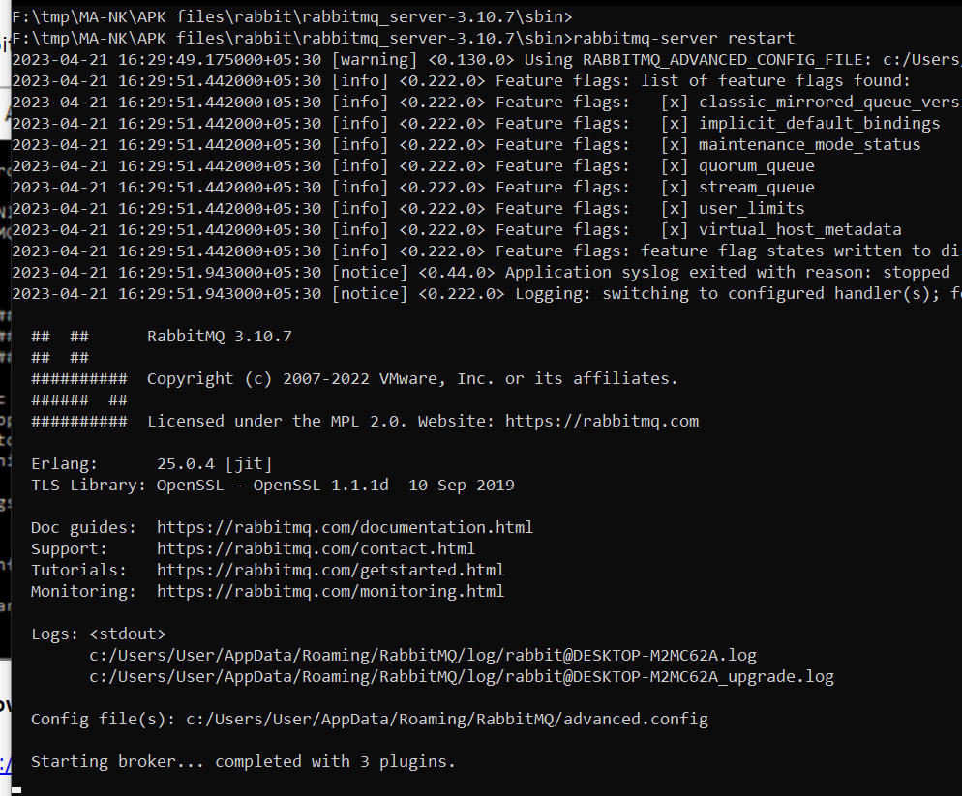

**6)Now open web browser (crome) and type following URL http://localhost:15672**

**7) It will show login page: here type username as “guest” and password as “guest” and login.**

**7)Now open 5 command prompts**

**8)On command prompt 1 start team service for that go inside teamservice project folder and write command :**

dotnet run --server.urls=http://0.0.0.0:5001 output:

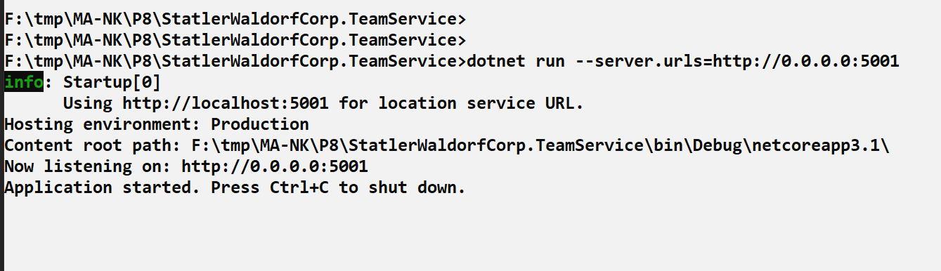

**9) On command prompt 2 start LocationReports service for that go inside LocationReporter project folder and write command :**

dotnet run –server.urls=http://0.0.0.0:5002 output:

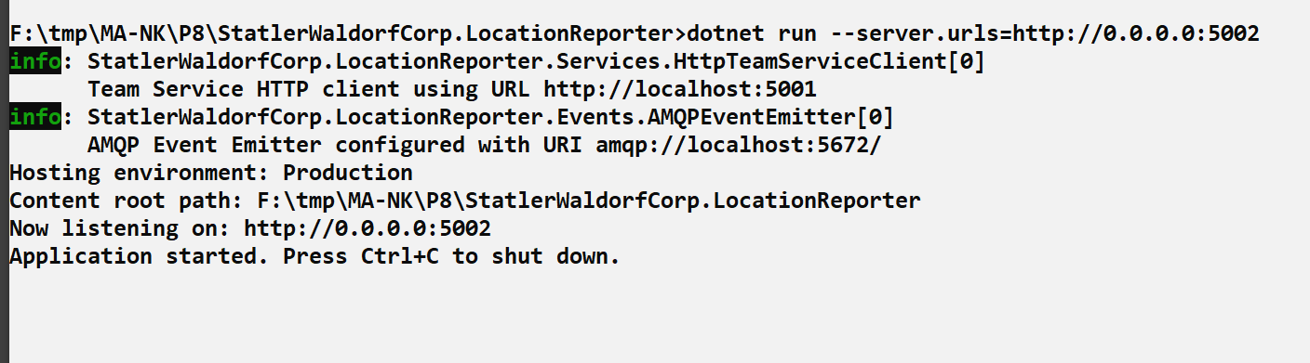

**10) On command prompt 3 start EventProcessor service for that go inside EventProcessor project folder and write command :**

dotnet run –server.urls=http://0.0.0.0:5003

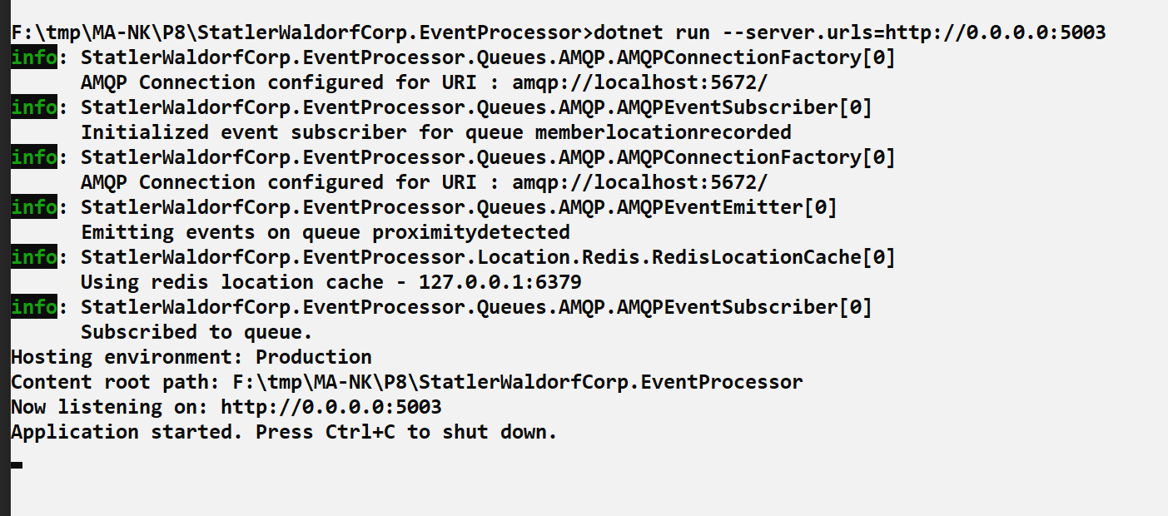

**11) On command prompt 4 start Reality service for that go inside Reality project folder and write command :**

dotnet run –server.urls=http://0.0.0.0:5004

**output:**

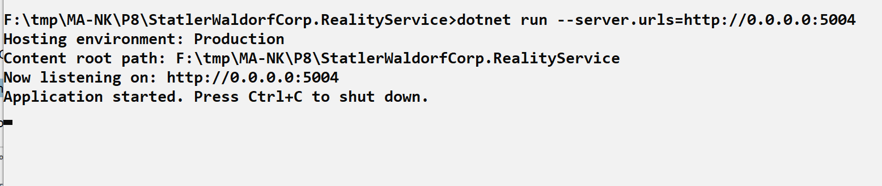

**12) Now run all commands on command prompt 5**

**Command: to add new team**

curl -H "Content-Type:application/json" -X POST -d "{\"id\":\"e52baa63-d511-417e-9e54-7aab04286281\", \"name\":\"KC\"}" http://localhost:5001/teams

**output:**

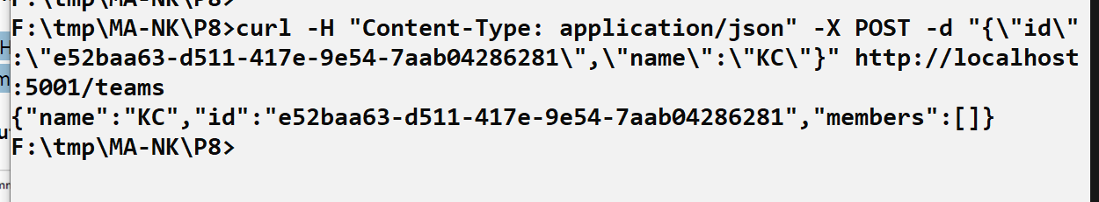

**Command : to add new member**

curl -H "Content-Type:application/json" -X POST -d "{\"id\":\"63e7acf8-8fae-42ce-9349-3c8593ac8292\", \"firstName\":\"Kirti\", \"lastName\":\"Bhatt\"}" http://localhost:5001/teams/e52baa63-d511-417e-9e54- 7aab04286281/members

**output:**

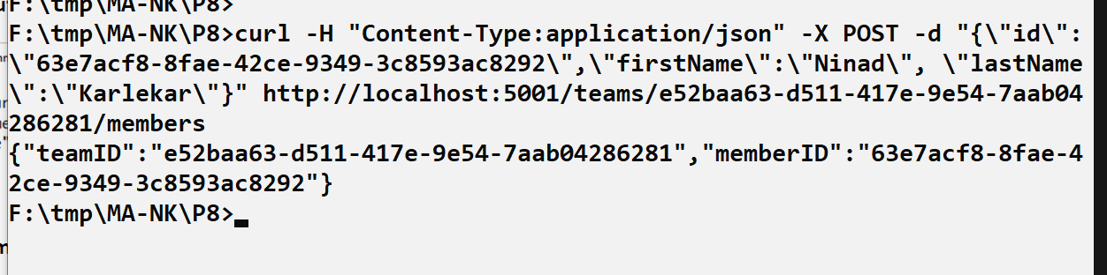

**Command: to add location of member**

curl -H "Content-Type:application/json" -X POST -d "{\"reportid\":\"67c3e69f-1580-4b2f-a9ff-2c5f3b8f0e1f\", \"origin\":\"1234\",\"latitude\":12.5,\"longitude\":12.5,\"memberId\":\"63e7acf8-8fae-42ce-9349- 3c8593ac8292\"}" http://localhost:5002/api/members/63e7acf8-8fae-42ce-9349-3c8593ac8292/locationreports

**output:**

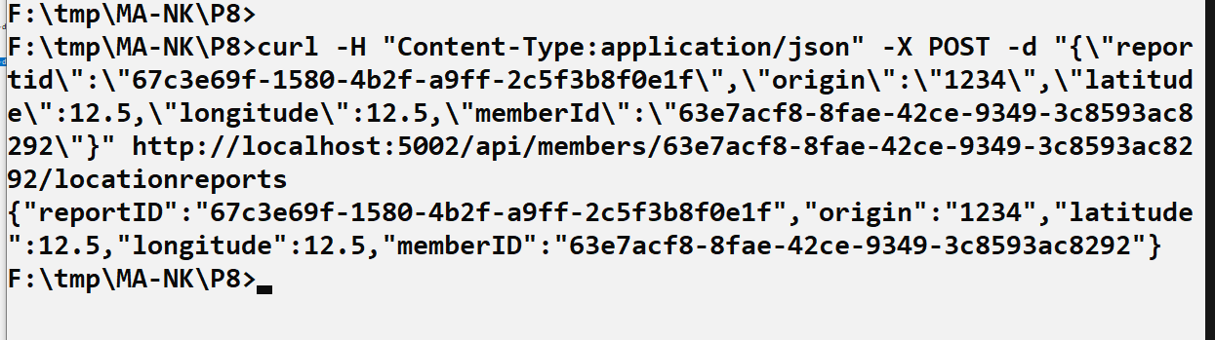

**Output of event processor shows event received**

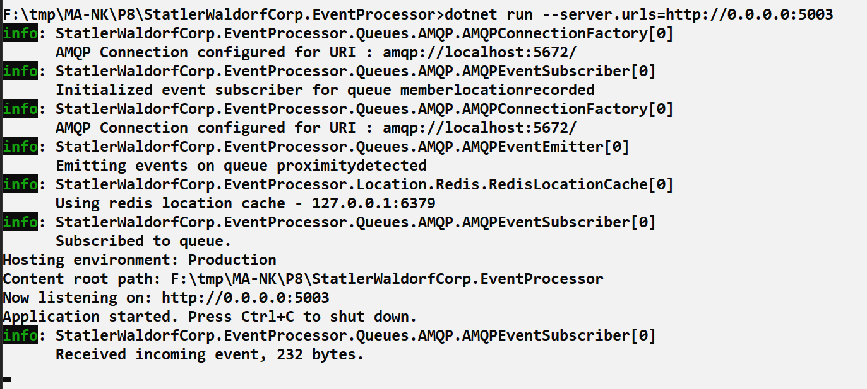

**Command : To add another member to same Team**

curl -H "Content-Type:application/json" -X POST -d "{\"id\":\"68e7acf8-8fae-42ce-9349-3c8593ac8292\", \"firstName\":\"Anushka\", \"lastName\":\"Bhatt\"}" http://localhost:5001/teams/e52baa63-d511-417e-9e54- 7aab04286281/members

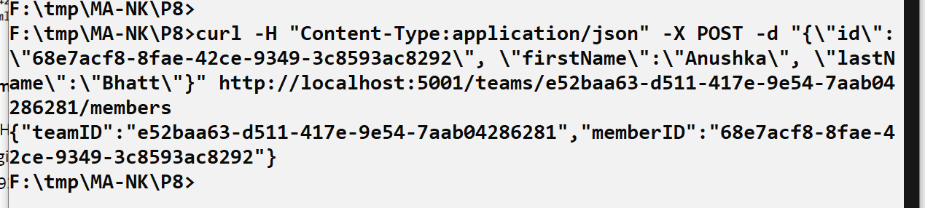

**Command : To add location of this another member of same team**

curl -H "Content-Type:application/json" -X POST -d "{\"reportid\":\"70c3e69f-1580-4b2f-a9ff-2c5f3b8f0e1f\", \"origin\":\"1234\",\"latitude\":12.7,\"longitude\":12.8,\"memberId\":\"68e7acf8-8fae-42ce-9349- 3c8593ac8292\"}" <http://localhost:5002/api/members/68e7acf8-8fae-42ce-9349-3c8593ac8292/locationreports>



